CSC 330: Artificial Intelligence

**Homework Assignment #1 – Uninformed Searching**

## Due on Friday, February 7, by the beginning of class

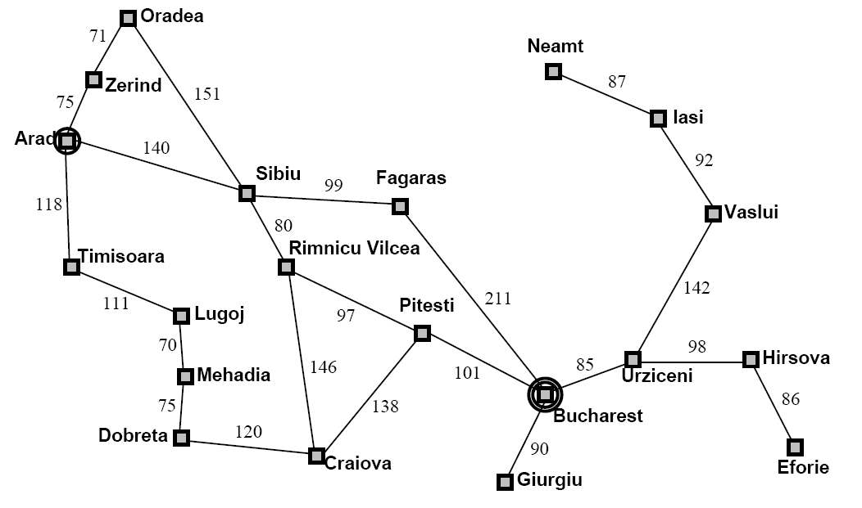

The above is a graph version of a road map of various cities in Romania. Questions 1 and 2 deal with this graph. For this homework, the distances between cities are irrelevant.

1. Show the results of performing a breadth-first search on the graph above. Assume that the start node is Arad, and the goal node is Bucharest. Label each node in the graph with the order in which it was first expanded (for example, Arad should be numbered 1). Show the final path found. Assume that if multiple nodes are generated at the same time, they are added to OPEN so that they will be **removed** in alphabetical order.
2. Show the results of performing a depth-first search on the graph above. Assume that the start node is Arad, and the goal node is Lugoj. Label each node in the graph with the order in which it was expanded (for example, Arad should be numbered 1). Show the final path found. Assume that if multiple nodes are generated at the same time, they are added to OPEN so that they will be **removed** in alphabetical order.
3. The **missionaries and cannibals** problem is usually stated as follows. Three missionaries and three cannibals are on one side of a river, along with a boat that can hold one or two people. Find a way to get everyone to the other side, without ever having more cannibals than missionaries on a single side of the river. This problem is famous in AI because it was the subject of the first paper that approached problem formulation from an analytical viewpoint (Amarel, 1968).

Draw a diagram of the complete state space (this is not as large as you might think). Omit states that are impossible or that violate the rules of the game. Also, only drawing each state once will help. I suggest starting with the start state and working out from there. For example, one non-graphical way to represent state is like this: *m* C *n* M B ||  *j* C *k* M, where || represents the river, *m* and *j* are the number of cannibals on the appropriate side of the river, *n* and *k* are the number of missionaries, and B represents the position of the boat. So, the initial state would be 3C 3M B || 0C 0M, and the goal state is 0C 0M || 3C 3M B.